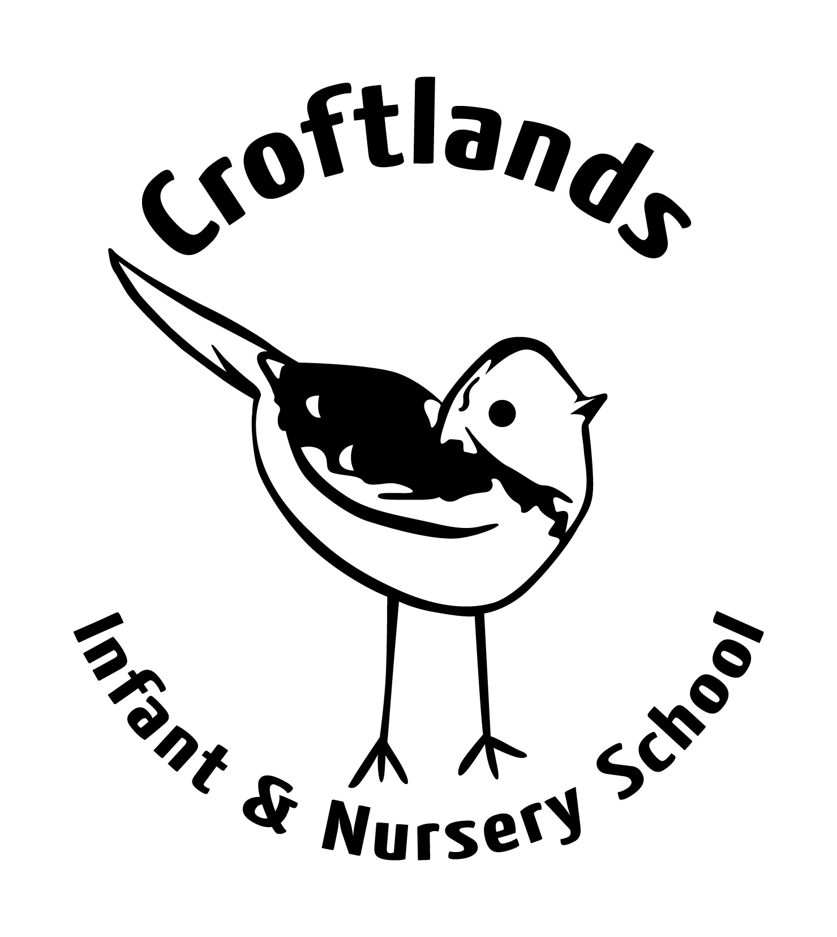
Head Teacher: Mrs Jo Procter
Oakwood Drive
Ulverston
Cumbria
LA12 9JU
Tel: 01229 586565
www.croftlandsinfantschool.co.uk
Thursday 6th September
Dear Parents / Guardians,
Welcome to Nursery (Sparrow Class) and to our school! We are looking forward to starting a new year!
We will welcome the children and work in our groups for some of the time. Mrs Hampshire will lead blue group and Miss Wright will lead green group, alongside our very experienced Teaching Assistants Mrs Eastwood and Miss Scarr. We will work very closely together to ensure the needs of all children are met. If you have any questions or concerns please do not hesitate to speak to any member of staff.
We are looking for parents to volunteer for our parent rota. This involves coming into Nursery for a morning, maybe once or twice a term, depending on numbers. We will keep you busy with jobs and you will have the opportunity to see what really happens in Nursery! This is open to Mum, Dad and Grandparents. We really appreciate your support, and the extra help enables us to plan for even more exciting activities! We will put a list on the notice board.
We will have given you a ‘hopes leaf’ to complete. If you have not already returned this, please do so as soon as possible. We want to know what you would like from us! We will refer back to these at the end of the year. Please also return your home to school profile and ensure we have seen your child’s birth certificate and proof of address.
Please ensure you can log into Tapestry. You should receive emails to let you know we have added photographs and observations to your child’s account. We will use this a lot during the induction week.
On our website http://www.croftlandsinf.cumbria.sch.uk you will find ‘Nursery News’; this is updated weekly. We will let you know what the children will be learning, activities they can take part in and anything they may need to bring from home. Additional reminders will be added to Class Dojo and for whole school news please refer to ‘our schools app’. Our long term and medium term planning is also added to the learning section of our website.
We will display letters, notices, the parent rota, our planning and timetable in the porch. Please read and keep up to date with all the fantastic things we will be doing in Nursery and school this year. The notes attached are a brief outline of the learning that will be taking place in Nursery this term. If you feel you can help with our topics in anyway please let us know.

Yours sincerely,

Mrs Hampshire, Miss Wright, Mrs Eastwood and Miss Scarr


Autumn 2018

Much of what we develop and learn this year will be taught through our topics. Our topics are; All About Me, Goldilocks and the 3 Bears and Autumn
After half term; Divali, Bonfire Night, India, The Gingerbread Man and Christmas.
It is through these topics we will cover the following 7 areas of the Early Years Foundation Stage curriculum:

Personal, Social and Emotional Development
When? Through all activities, everyday occurrences and especially planned ‘Circle Time’ activities
We will be working on:

- playing alongside others
- separating from main carer with support and encouragement from a familiar adult
- expressing own preferences and interests
- responding to a few appropriate boundaries, with encouragement and support
Supporting your child at home:
We would like to work closely with you in supporting your child’s development in this area. In Nursery, we use Class Dojo’s where we reward positive behaviour and we will share the children’s successes with you. We will also speak to you about any concerns we may have. We will choose a ‘Superhero’ from each group who will help with classroom jobs that day and a ‘Star of the week’ to take home ‘Stitch’ our class bear for the weekend.
Communication and Language
When? Through weekly phonics activities, Nursery News, topic experiences and play
We will be working on:
- recognising and responds to many familiar sounds
- understanding simple sentences
- developing understanding of simple concepts
- beginning to talk about people and things that are not present

- using language as a powerful means of widening contacts, sharing feelings, experiences and thoughts
- using simple sentences
Supporting your child at home:
Listening out for familiar sounds is a lovely activity to do anywhere! For example, walking to Nursery you might hear a motorbike. Giving children simple instructions helps develop understanding and lots of talk, introducing new vocabulary, is a great way to extend children’s speaking skills. In Nursery, we will always encourage children to speak in full sentences and to use the correct words for objects.
Physical Development
When? Through PE, play and everyday activities
We will be working on:

- beginning to balance blocks to build a small tower
- making connections between movement and marks
- running safely on whole foot
- showing a desire to help with dressing
- drinking well without spilling
Supporting your child at home:
There are lots of fun ways to help children develop their fine and gross motor control – drawing with their finger in shaving foam, finger painting, manipulating playdough, paintbrushes and water outdoors, large paper for painting or even counting out Smarties! We will have one PE session per week in the hall. We will let you know ASAP which day this will be. Please make sure your child is wearing socks and shoes that they can easily take off and put on. For safety reasons, children’s earrings must be removed for PE. Please bring a pair of wellies to keep in Nursery. We will be playing and learning a lot outside, so please bring suitable outdoor clothing.
Literacy
When? During story times, planned activities and play

We will be working on:
- showing interested in books and rhymes
- repeating words or phrases from familiar stories
- See Communication and Language and Physical Development
Supporting your child at home:
Reading to your child every day has a huge impact on their learning and development, even before they begin to read themselves. Sharing books, rhymes and poems develops children’s speaking and listening skills, early reading skills and imagination. Library books will be available in the porch. Please write in the record book under your child’s name the date, book title and return date if you wish to borrow a book.
Mathematical Development
When? During everyday occurrences, planned activities and play
We will be working on:

- Saying some counting words randomly
- Selecting a small number of objects from a group
- reciting some number names in sequence
- recognising and naming shapes
Supporting your child at home:
Children love to count, especially sweets and favourite toys! These are both great motivators to help children begin to count in sequence and then touch count independently. You could line up cars for a race and count them, count farm animals into a pen, count beads on a necklace or chocolate buttons onto a cake.
Understanding of the World
When? During topic activities, Nursery News, gardening and play
We will be working on:
- showing interest in stories about themselves and their family
- enjoying pictures …about themselves

- (in pretend play), imitating everyday actions and events from own family and cultural background, e.g. making and drinking tea
- exploring objects by linking together different approaches
- enjoys playing with small-world models
- seeking to acquire basic skills in turning on and operating some ICT equipment
Supporting your child at home:
Every Monday is ‘Nursery News’, which provides the children with an opportunity to share their home experiences with their friends. Please see the notice board for further details.
Expressive Arts and Design
When? Through topic activities and play
We will be working on:

- beginning to move to music, listen to or join in rhymes or songs
- noticing the effects of making movements which leave marks
- creating sounds by banging
- expressing self-through physical action and sound
- beginning to make-believe by pretending
Supporting your child at home:
There are lots of TV programmes and online resources that help children move to music, such as CBeebies. In Nursery our first PE block is dance, which will support children’s movements and ideas in expressing themselves. We love to role-play in Nursery and will adapt our role-play area during the course of the year. We like to use real resources so if you have any objects at home that may be of use please let us know e.g. soft toys, pet bowls, animal carriers, used tins or boxes of food or treats for a vets, broken hairdryers / straighteners, empty spray bottle for a hairdressers.

